Paschal Band Handbook and Fees Acknowledgment Form

Please return this form to Mr. Sawyer prior to Friday August 18, 2023.

************************************************************************

We have received and read our copy of the 2023-2024 Paschal Panther Band Policies and Procedures. We accept that these policies will govern the Paschal Panther Band and will make every effort to adhere to them. Additionally, our signatures below indicate that we’ve received and acknowledge the 2023-2024 Band Fees. We understand that these fees are required of all students and will not be waved if we choose to leave (or are removed) from the program. Students must have previous years fees paid off entirely and at least a $25 deposit down for the 23-24 school year to be able to board the bus for the 1st football game.

Member Name (Printed) Parent Name (Printed)

Band Member Signature Parent Signature

************************************************************************

2023-2024 Paschal Band Fees:
Wind Members : | $400.00
Guard Members: | $450.00

Percussion Members : | $450.00
Winter Guard member Fees: Due by March 1st | $100.00
Jazz Fees : Due by March 1st | $150.00

PAYMENT OPTIONS: | Mark OPTION
Option #1 - Full payment - ☺
Option #2 - THREE (3) equal payments ON OR BEFORE 8/18, 9/22, and 11/1
Option #3 - Minimum deposit of $25 by 8/18 and _________ equal payments every ______ weeks. (Must be paid in full by 12/1/2023 to avoid a record hold.)
Handbook/Fees form, a deposit, and a previous year balance of ZERO
(Veterans only) is required by 8/18/2023 before your student can perform
as a member of the 2023 Paschal Panther Band.
Monday, July 24, 2023

Dear Students and Parents,

As the school year rapidly approaches, I want to make you aware of several purchases that need to be handled as soon as possible. Each item is listed in the table below. You can pay with cash, check, or credit card. Please include your DRIVER’S LICENSE NUMBER on ALL CHECKS.

CHECKS should be made out to Paschal HS Band Boosters.
CHECKS must be written in BLUE OR BLACK INK.

Money must be in a sealed envelope, clearly marked with student’s name and band class, and placed in the box by the band office. Fess may also be paid online at www.paschalband.com If paying by check or cash see Mr. Walker for a receipt before depositing funds into the bos.

Item | Cost | Who
Performance Shoes | $41.00 | New Members
Dry-fit Practice Shirt | $25.00 | New Members
Extra Show T-Shirt | $25.00 | ALL
Performance Gloves/Earplugs (Perc) | $7.00 | ALL
Total – Wind & Percussion Member Fee | $400.00 | Winds
Total – Color Guard & Percussion Member Fee | $450.00 | Guard & Perc.
School owned Instrument use fee Check or  Cash only Checks to Paschal High School to Mr. Strahan. | $80.00 | Wind Instrument Renters

Although the beginning of the school year is often an overwhelming time for student fees, please understand that these items must be purchased with the funds provided by the students.

As these items are necessary for our very first performances, you must turn in your Handbook/Fees Acknowledgement Form and your deposit/payment by August 18^{h}. Without this form on file signed by a parent, your student will not be able to perform, and these missed performances will affect his/her grade.

As members of the Fort Worth Independent School District, we are fortunate to have EXTREMELY LOW costs for enrollment in band. Students across the metroplex often pay in excess of $1500 per year to perform as a part of the band program. We are thankful for the high value that FWISD places on music education and ask that you will quickly and graciously handle your portion of the supply requirements. Student booster scholarships are available if assistance is needed. Please inquire with a band director for details.

If you have any additional questions, please feel free to contact me. Thanks for your continued support! We’re looking forward to a GREAT YEAR!!!
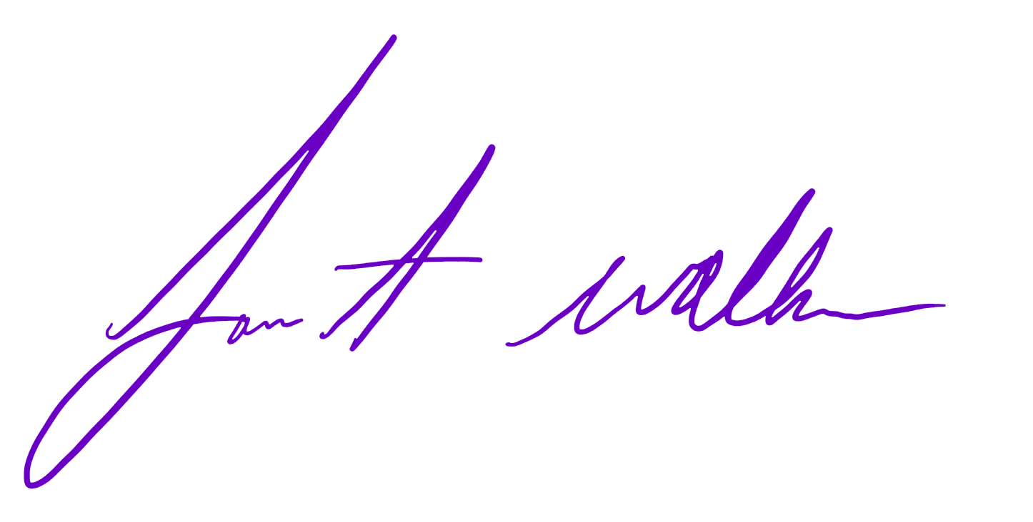
Lance A. Walker
Director of Bands
Paschal High School
817-814-5071
lance.walker@fwisd.org

